OOPS part-1

- Write a Java program to swap two variables without using third variable.
Source code:
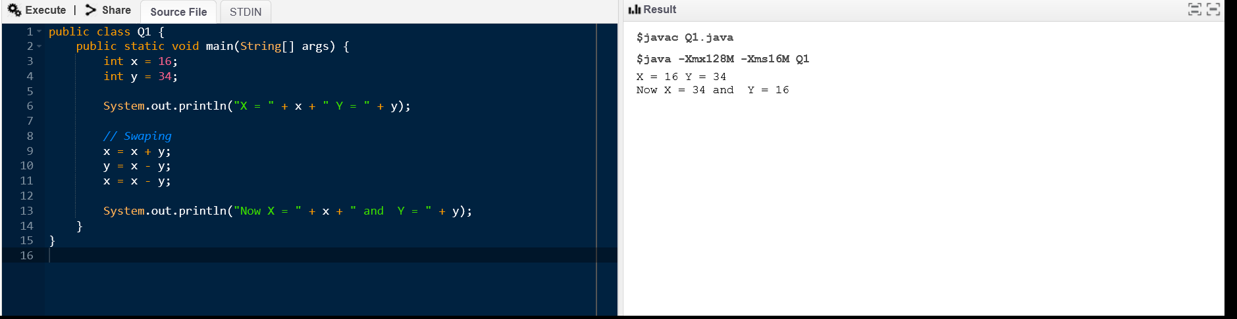

Output:


2. Write a program to find the average of five numbers. The numbers should be entered at run
time.
Source code:
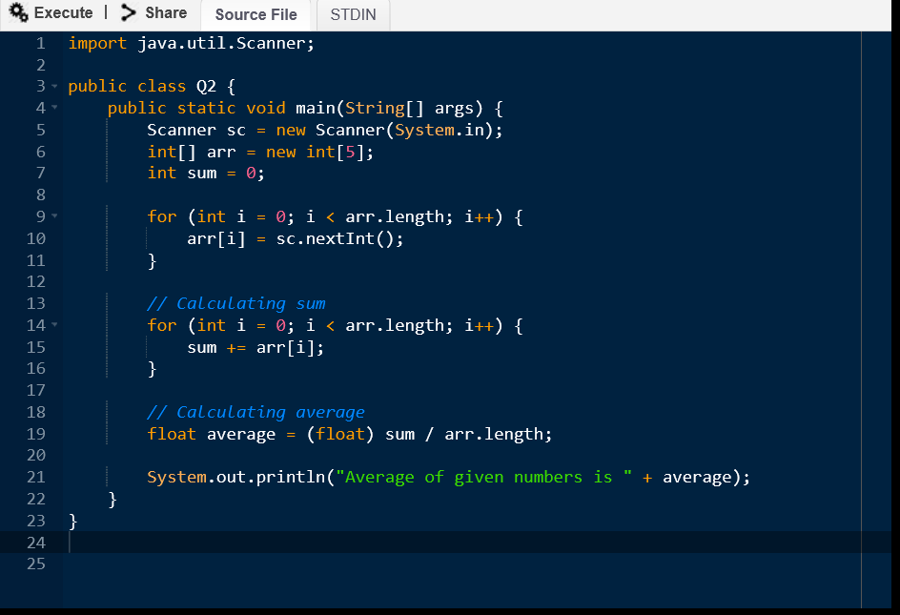
Input:
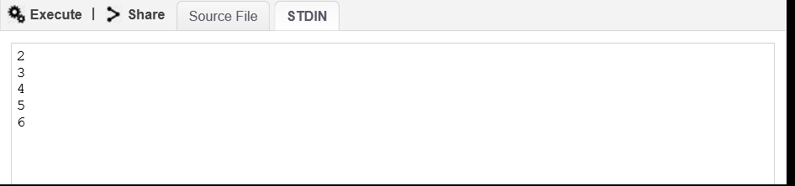
Output:
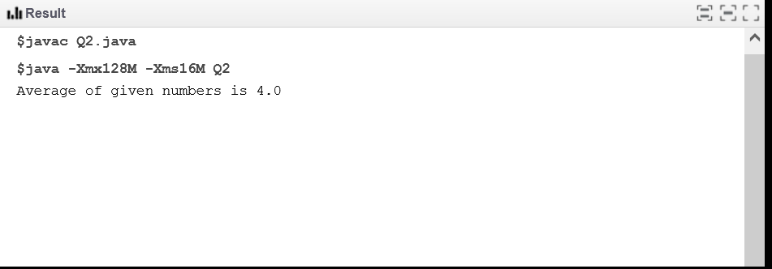
3. Write a Java program that takes two numbers as input and display product of two numbers.
Source code:
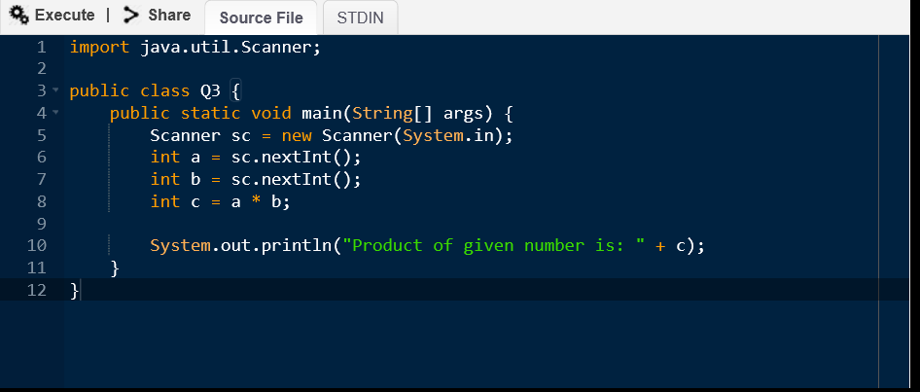

Input:
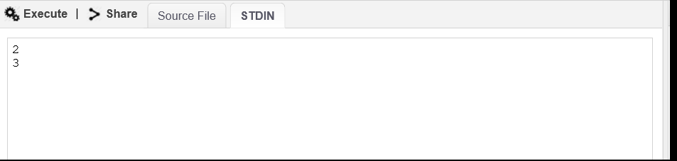
Output:
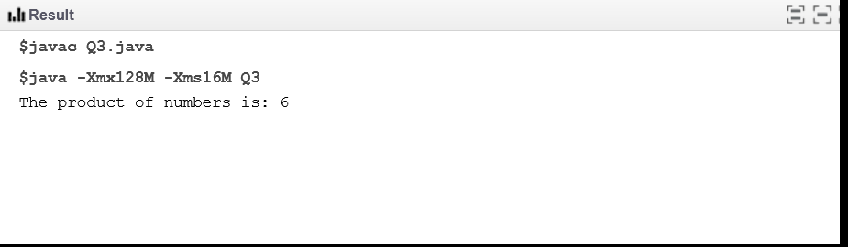
4. Write a java program to create calculator using switch case where two numbers and one
operator must be entered at runtime.
Source code:
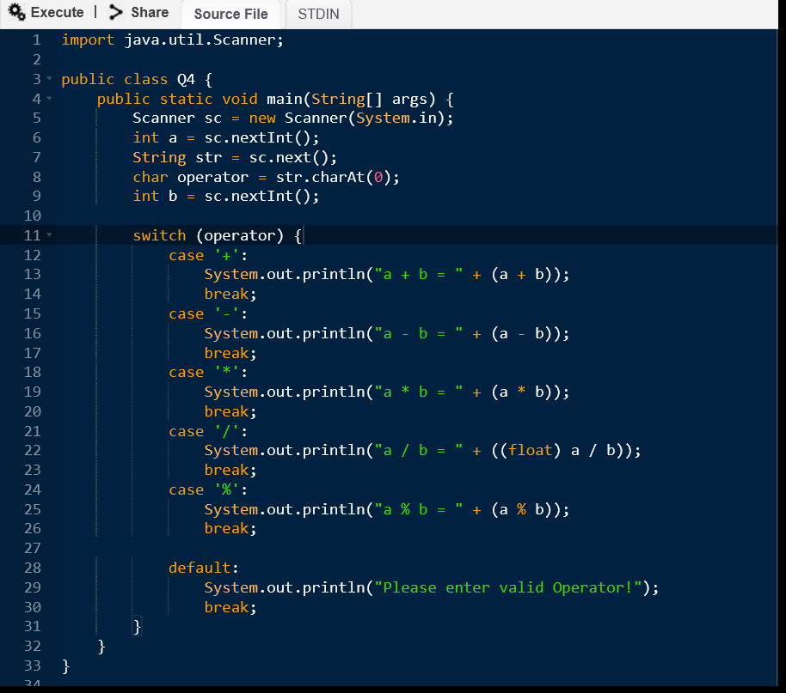

Input:
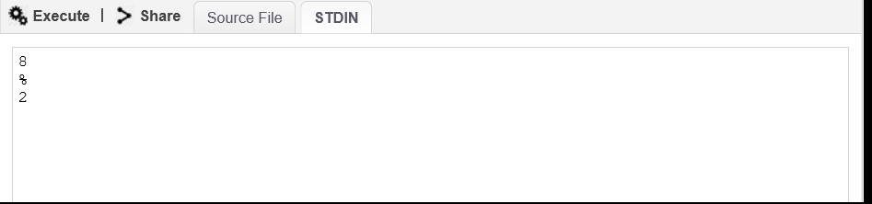

Output:
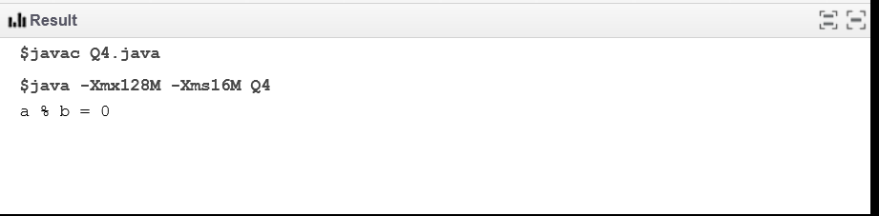
5. Write a Java program to print the area and perimeter of a circle.
Source code:
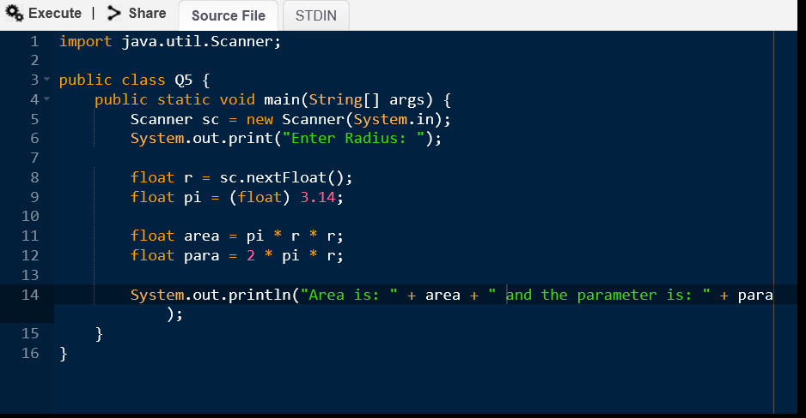

Input:
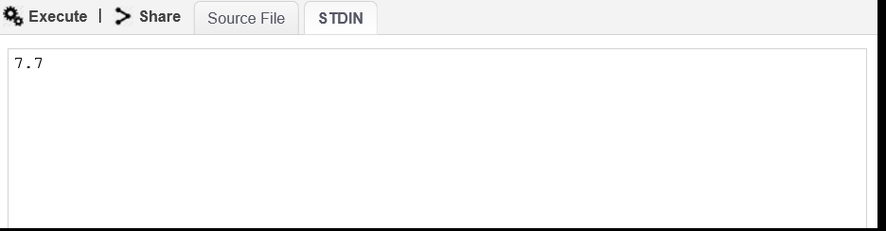

Output:
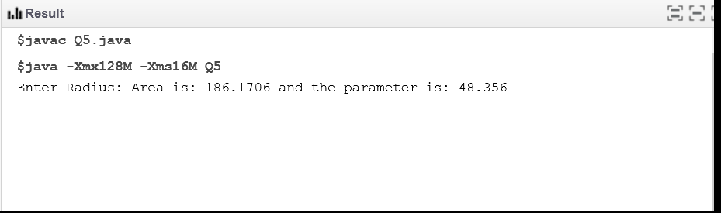
6. Write a Java program to compare two numbers.
Source code:
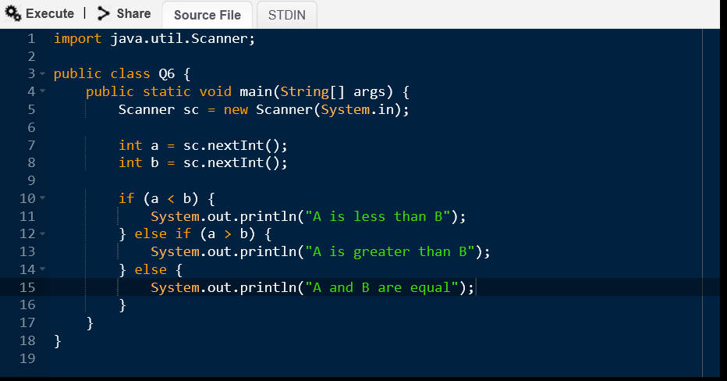
Input:
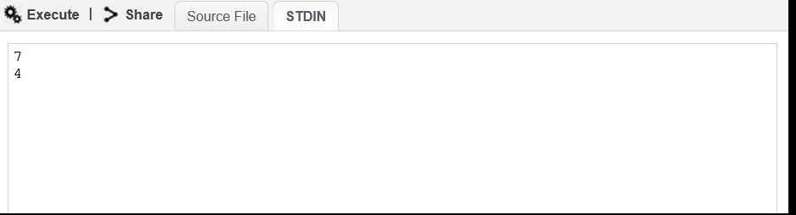
Output:
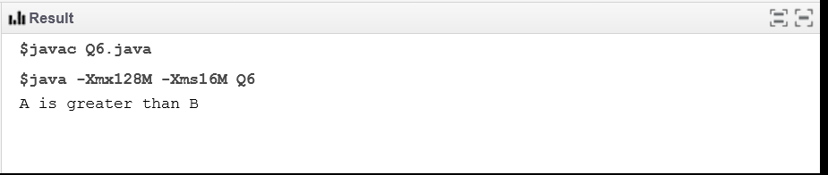
7. Write a java program to check whether Java is installed on your computer.
Expected Output:
Java Version: 1.8.0_71
Java Runtime Version: 1.8.0_71-b15
Java Home: /opt/jdk/jdk1.8.0_71/jre
Java Vendor: Oracle Corporation
Java Vendor URL: http://java.oracle.com/
Java class path: .
Source code:
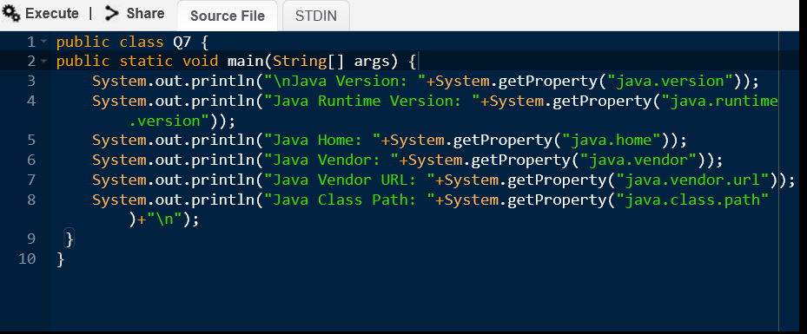

Output:
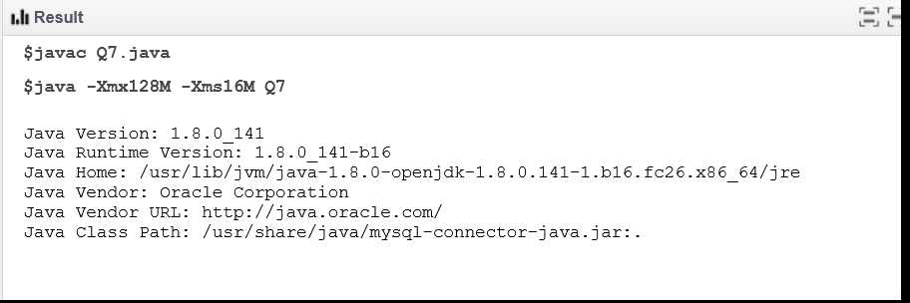
8. Write a Java program that takes a number as input and prints its multiplication table upto 10.
Source code:
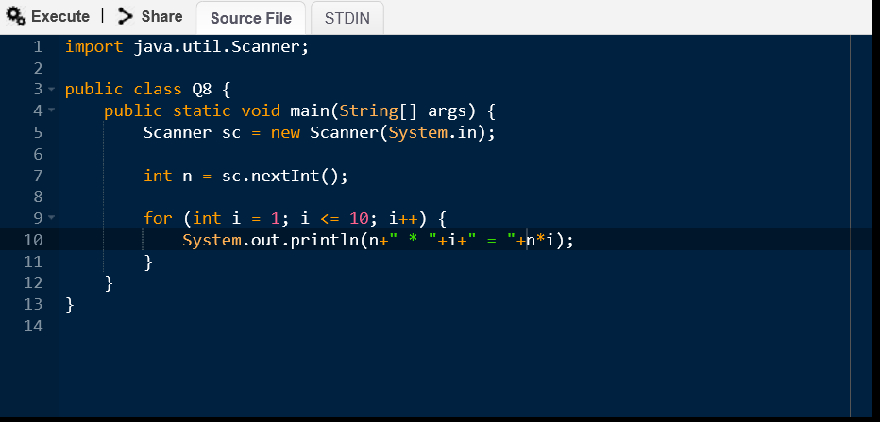

Input:
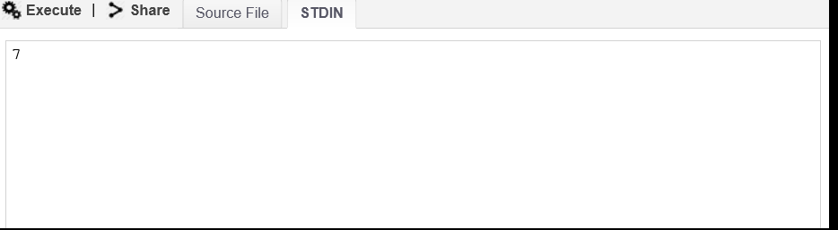
Output:
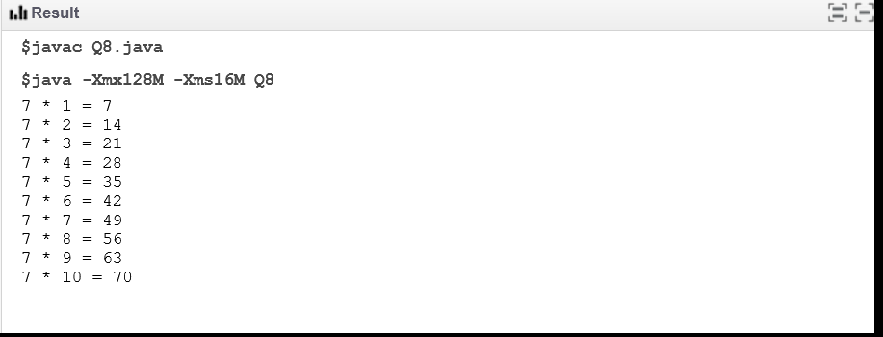
9. Write a java program to check whether the entered number is Armstrong or not.
Source code:
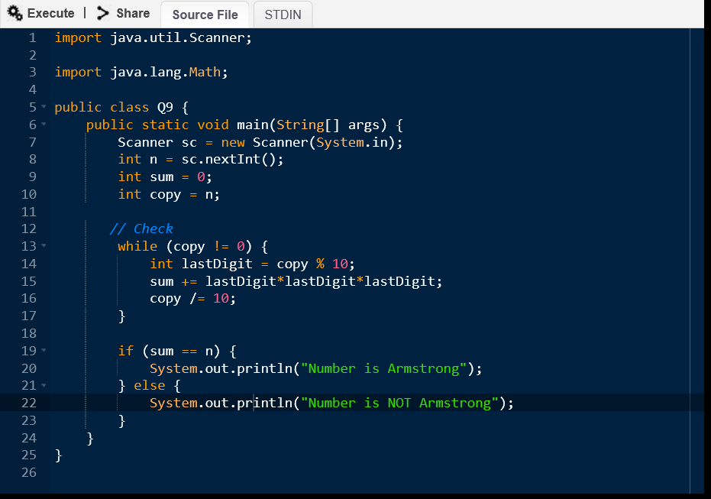
Input:
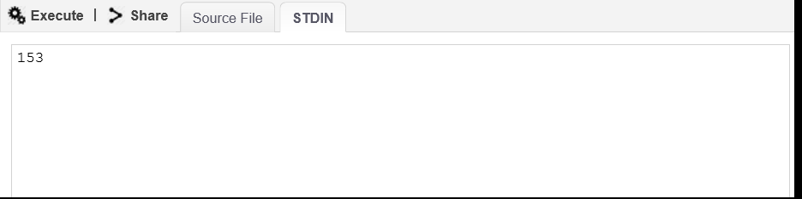
Output:
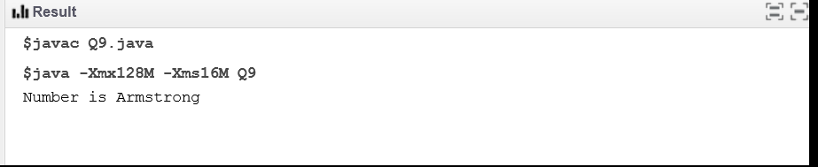
10. Write a Java program to compute the area of a hexagon.
Source code:
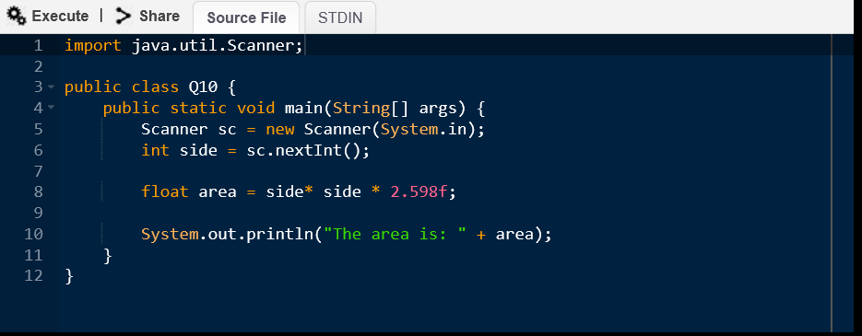
Input:
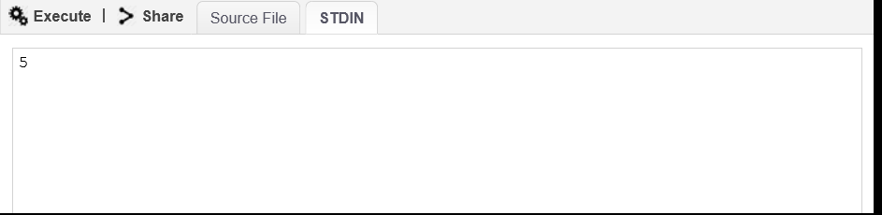
Output:
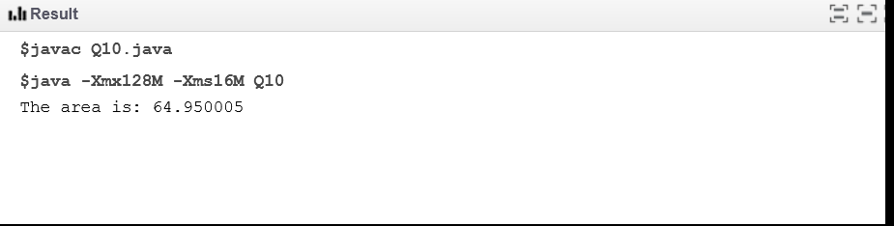
11. Write a program in java to convert temperature from Celsius to Fahrenheit using if -else.
Source code:
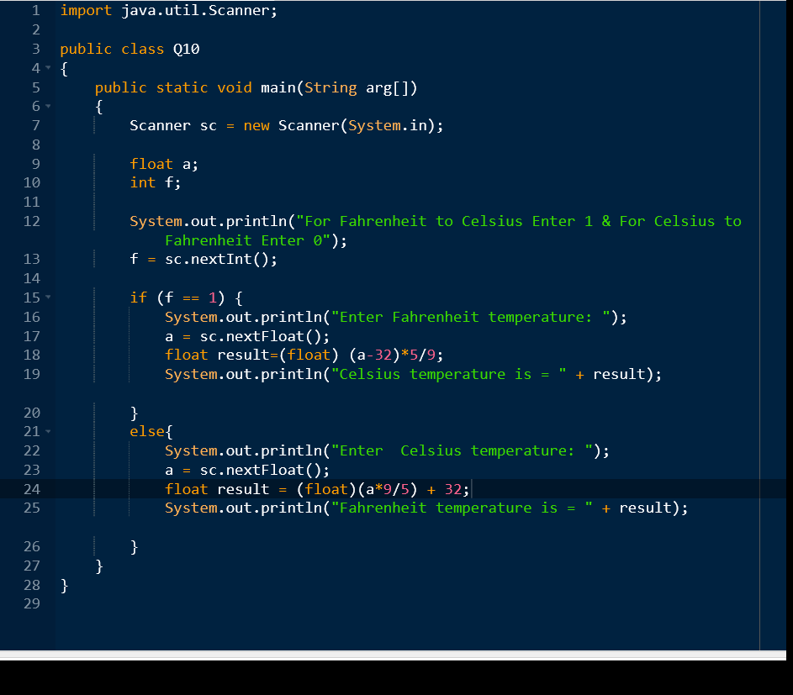
Input:
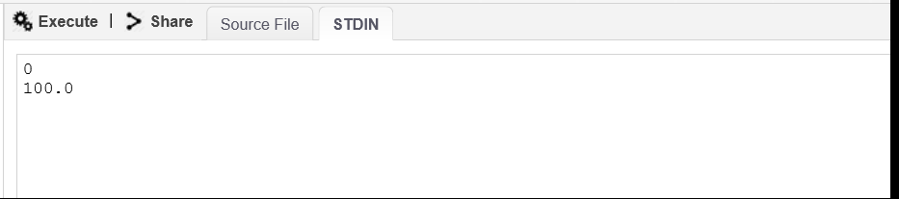
Output:
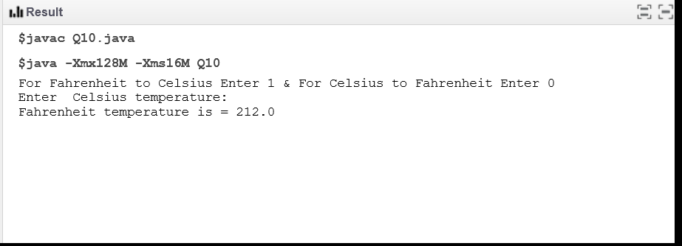
12. Write a java program to calculate the factorial of an integer.
Source code:
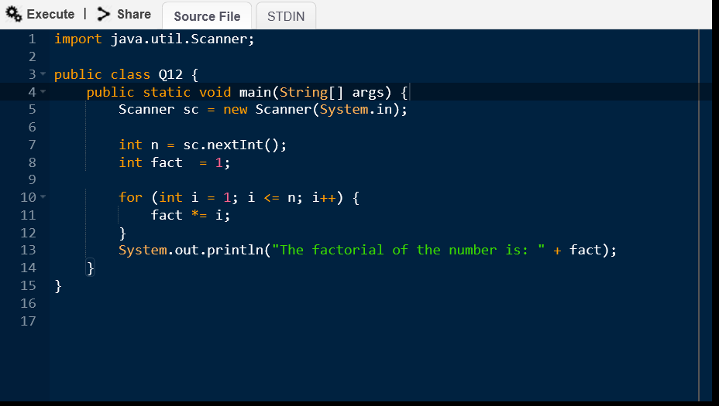
Input:
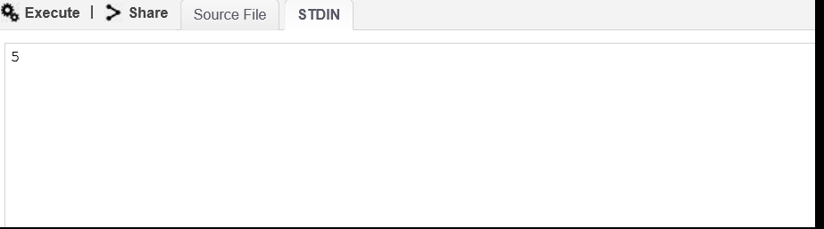
Output:
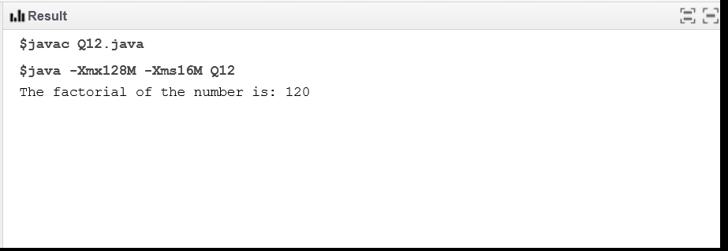
13. Write a java program to compute the sum of the digits of an integer.
Source code:
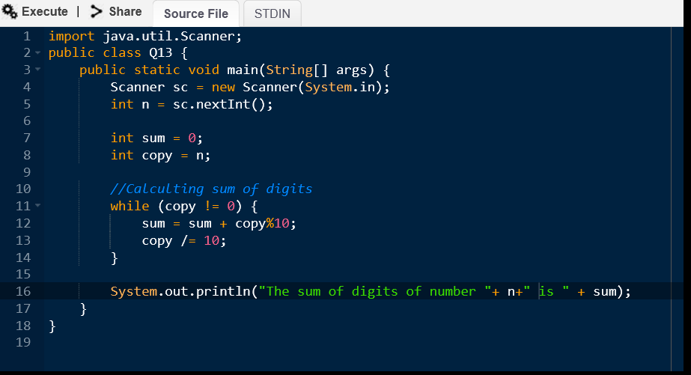
Input:
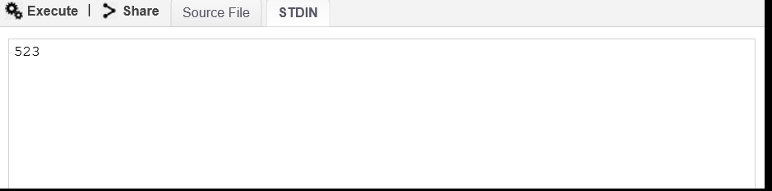
Output:
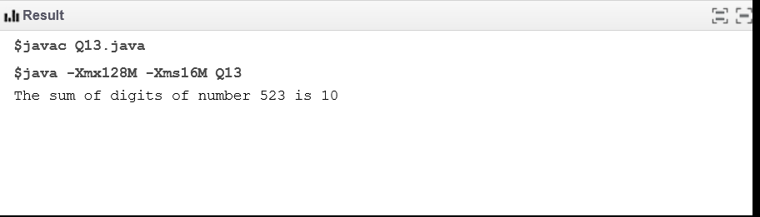
14. Write a java program to print the max value and min value of integer data type.
Source code:
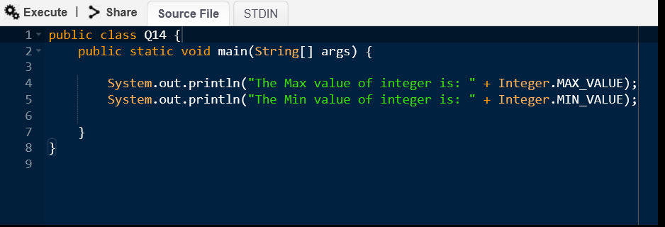

Output:
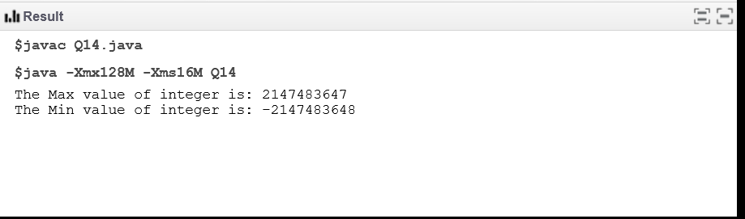
15. Write a java program to take 5 integer number as a command line argument then print the
average of those numbers.
Source code:
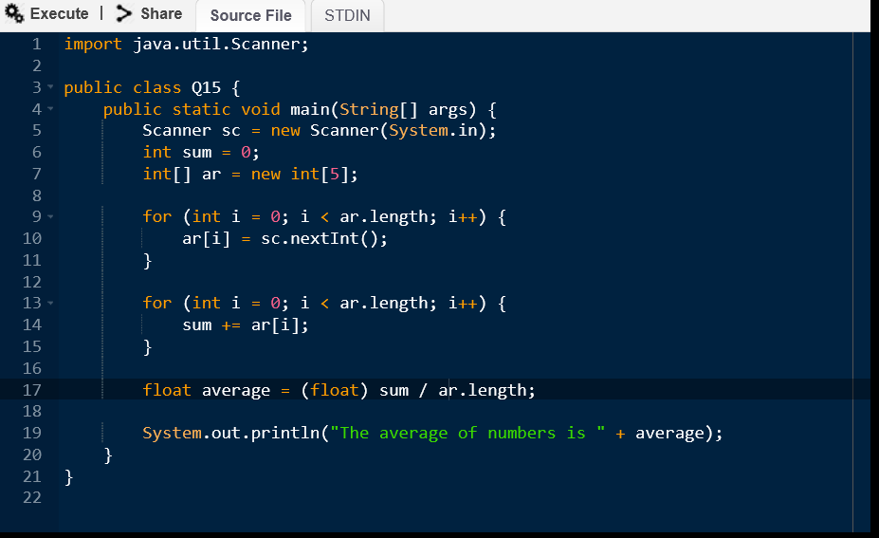
Input:
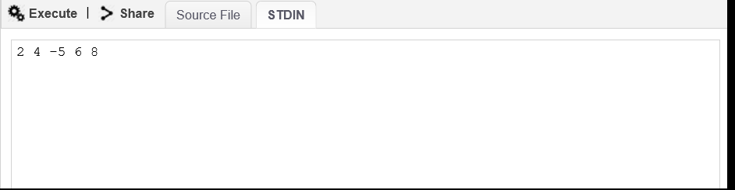
Output:
